Market Monitor - Afghanistan - 2026-06

Highlights
In June 2026, Afghanistan's markets saw a broad decrease in the cost of key food items compared to the previous month, providing some relief to consumers. However, the overall cost of food remains elevated compared to one year ago.
The national average cost of the standard food basket decreased to AFN 554.9 (↓1.5% MoM), but remains 6.2% higher than in June 2025 (↑6.2% YoY).
The monthly decrease was led by significant price drops in sugar (↓5.0%), wheat (↓4.0%), and high-quality rice (↓3.2%). Annually, rice remains a key concern with prices 31.2% higher than last year, the largest increase among all monitored food items.
Key Drivers:
- Widespread monthly price reductions across nearly all monitored food staples, with only salt showing a minor increase.
- Sharp price declines in high-impact commodities, particularly sugar (↓5.0%) and key cereals like wheat (↓4.0%).
- A stable Afghani (AFN) exchange rate against the USD, which helped contain potential price pressures from imported goods.
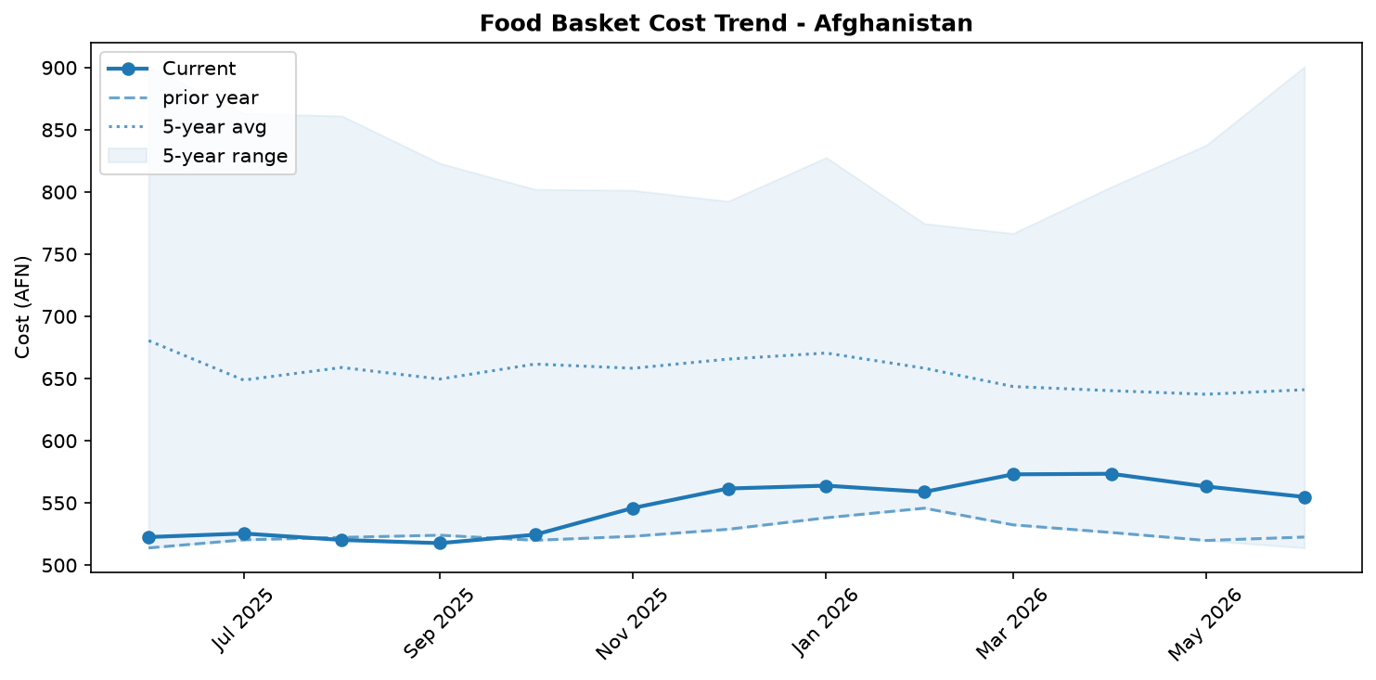
Food basket cost trend

Market Overview
Market conditions in June 2026 were characterized by a welcome, albeit potentially temporary, easing of food prices. The national average price of the food basket decreased by 1.5% month-on-month, reversing the inflationary pressures observed in previous months. This deflationary trend was primarily driven by widespread price drops across key food staples, most notably sugar (-5.0%), wheat (-4.0%), and high-quality rice (-3.2%). Favorable market fundamentals, including adequate commodity availability from ongoing harvests and sustained trade, underpinned this recent price relief. The continued stability and year-on-year strength of the Afghani exchange rate also played a crucial role in containing the cost of imported goods. Despite the positive monthly development, household purchasing power remains under pressure, as the food basket is still 6.2% more expensive than in June 2025. Looking ahead, the significant and ongoing influx of returnees from neighboring countries is expected to increase aggregate demand, posing a considerable upside risk to prices once the effects of the current harvest season diminish.

Commodity Analysis
An analysis of individual commodities reveals a broad-based, month-on-month price decline in June, though year-on-year trends vary significantly. Sugar prices saw the sharpest monthly drop at -5.0%, providing recent relief from a steep 21.9% annual increase. Similarly, high-quality rice became 3.2% cheaper month-on-month, but it still records the highest year-on-year inflation among all listed items at a substantial 31.2%. The price of low-quality wheat flour fell by a modest 1.0%, influenced by a larger 4.0% drop in the price of raw wheat; however, it remains 11.1% more expensive than a year ago. Cooking oil prices also decreased by 1.8% from the previous month but are still 3.0% higher annually.
In a notable contrast, pulses were the only monitored commodity to become cheaper on both a monthly (-1.3%) and annual (-12.3%) basis, indicating sustained price relief for this staple. Salt was the sole outlier, running counter to the general trend with a price increase of 1.5% month-on-month and 9.8% year-on-year, suggesting unique supply or demand pressures for this specific item.
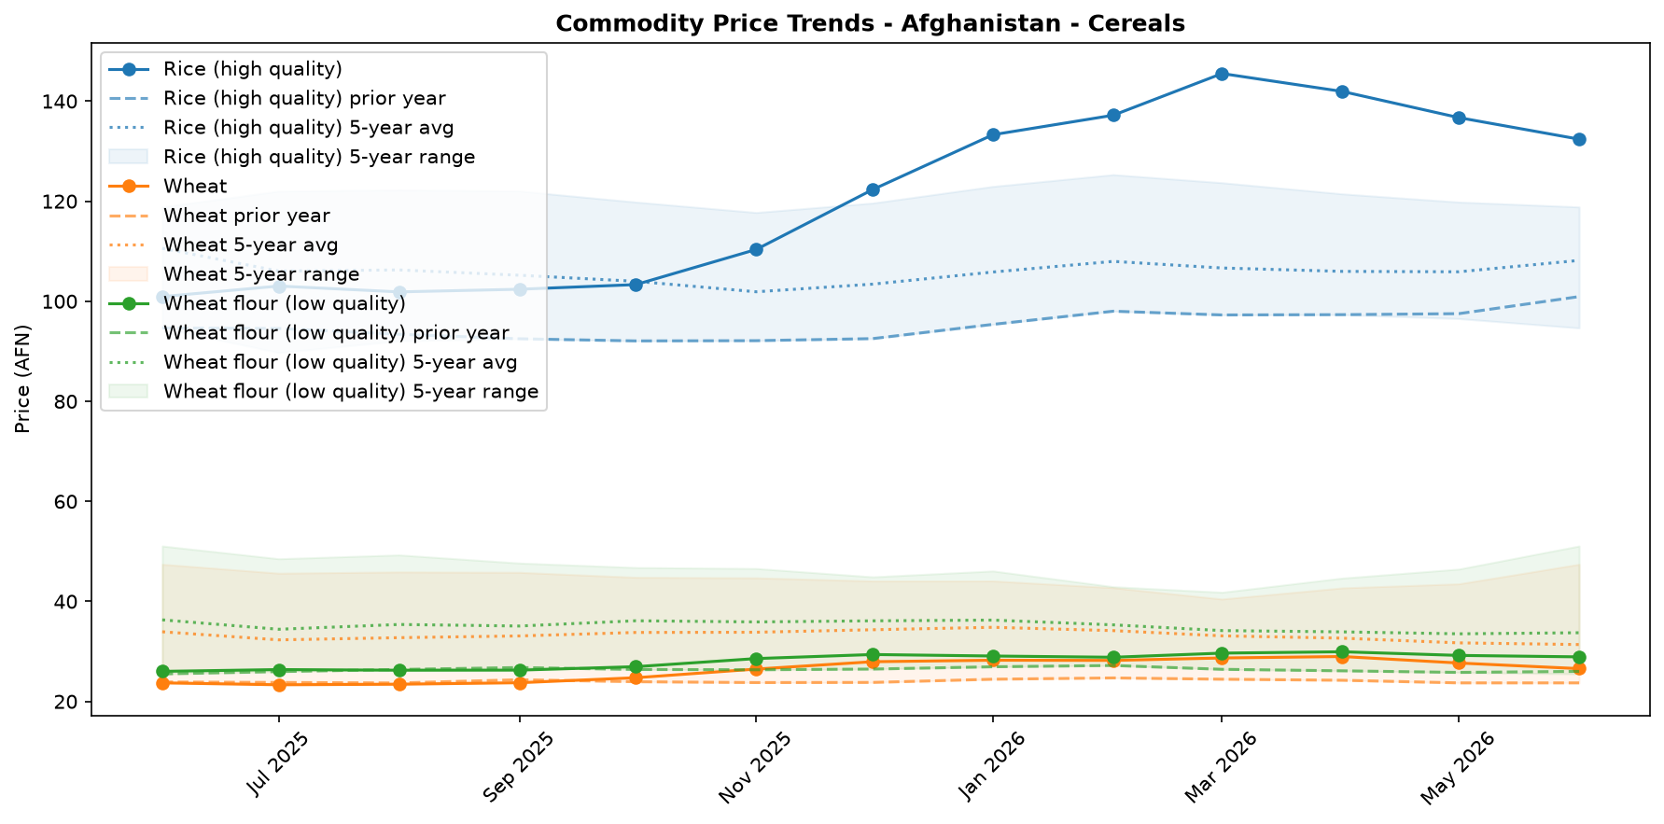
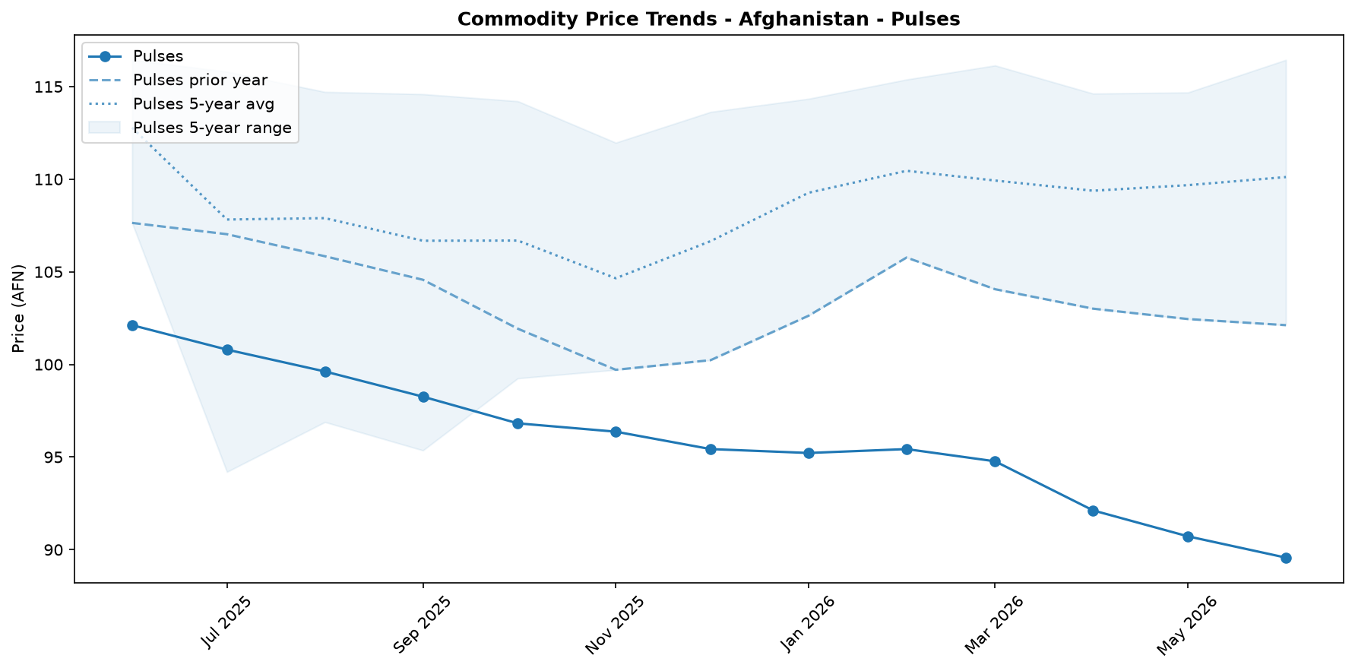
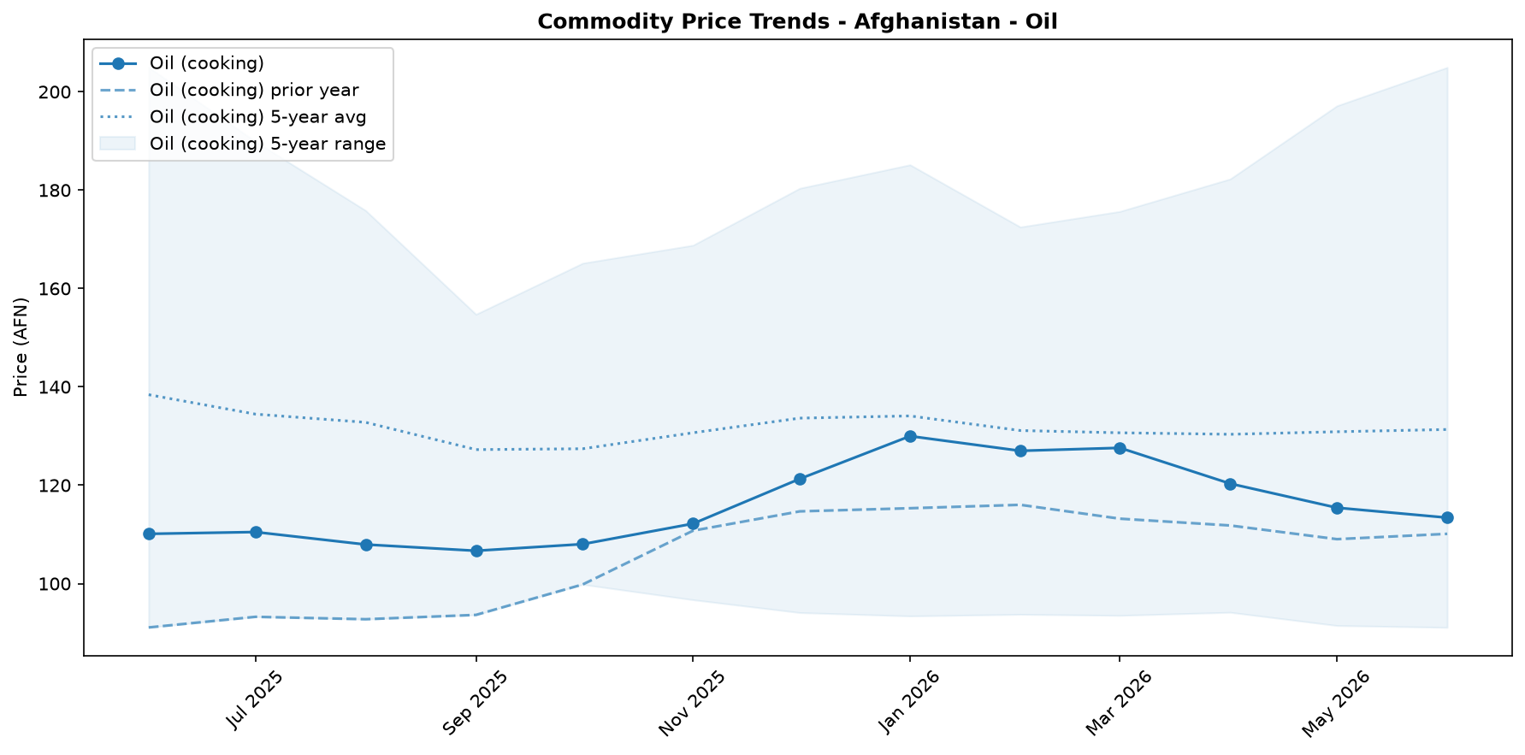
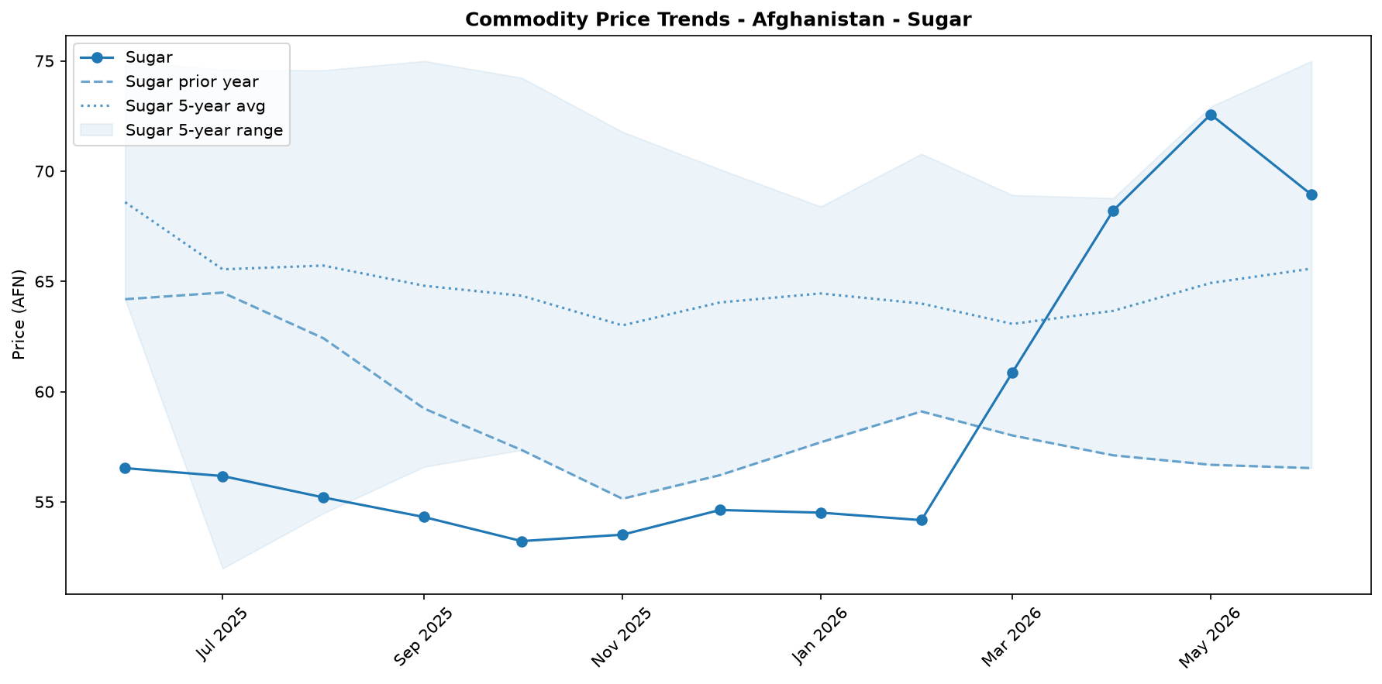
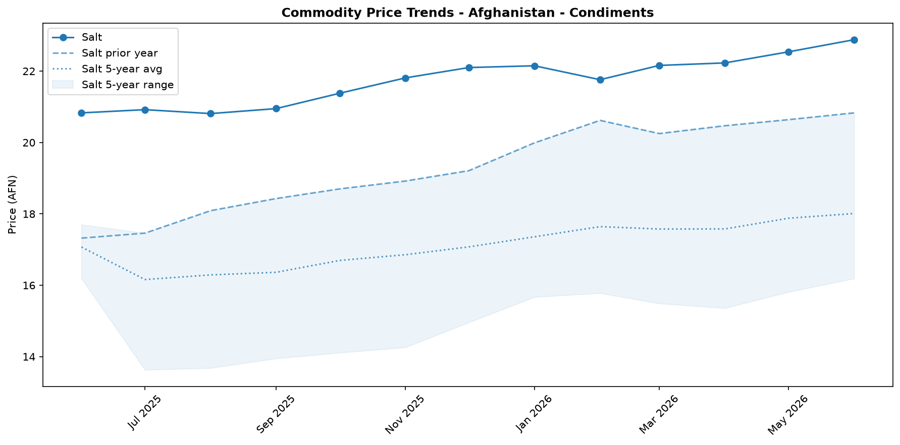

Regional Highlights
While the national trend points to a 1.5% month-on-month decrease in the cost of the food basket, market conditions can vary significantly across different regions of Afghanistan. The overall decline reflects improved commodity availability reported in markets nationwide, supported by the current harvest season. However, this national average may mask localized price pressures.
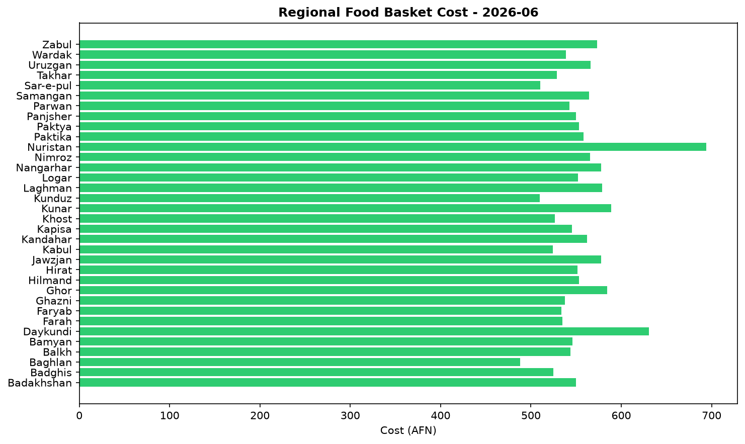
For instance, contextual reports from two months prior (April 2026) highlighted that Baghlan province was experiencing the country's highest month-on-month inflation at +5.5%, a stark contrast to the deflationary environment observed nationally in June. Current regional data is not available to confirm if this localized pressure in Baghlan has since subsided in line with the national trend. This disparity underscores the importance of continued sub-national monitoring to identify and understand localized shocks that may impact food security for vulnerable populations, even when the national picture appears to be improving.

EXCHANGE_RATE Analysis
The Afghan Afghani (AFN) exchange rate remained stable, closing the month at 63.5 AFN per USD. Month-on-month, the currency appreciated slightly by 0.64 percent, a marginal change that helps to modestly reduce the cost of imported goods. The longer-term trajectory shows significant strengthening, with the AFN appreciating by 9.56 percent on a year-on-year basis. For an import-reliant country like Afghanistan, this continued stability and appreciation are positive developments. They help to contain potential price increases for key imported commodities, including wheat, rice, cooking oil, and fuel, thereby supporting the purchasing power of vulnerable households.

References
- [rw_4217254] ReliefWeb (2026-06-22) Data for Afghanistan: Afghanistan Consumer Price Index (CPI) Report — April 2026
https://reliefweb.int/node/4217254
- [rw_4217179] ReliefWeb (2026-06-22) Afghanistan: Weekly Market Report: Issue 300: Week 3 – June 2026
https://reliefweb.int/node/4217179
- [rw_4217041] ReliefWeb (2026-06-19) Middle East Emergency: Three-Month Impact Report (March - May 2026)
https://reliefweb.int/node/4217041
- [rw_4216738] ReliefWeb (2026-06-17) Afghanistan | Population Movement (Returnees) - Operation update #5 (12-month update) (MDRAF018)
https://reliefweb.int/node/4216738
- [rw_4216714] ReliefWeb (2026-06-17) Atrocity Alert No. 487: Sudan, Afghanistan and Nigeria - Global Centre for the Responsibility to Protect
https://reliefweb.int/node/4216714
- [rw_4216641] ReliefWeb (2026-06-17) Hunger Hotspots FAO-WFP Early Warnings on Acute Food Insecurity - June to November 2026 outlook
https://reliefweb.int/node/4216641
- [rw_4216603] ReliefWeb (2026-06-17) REACH Afghanistan Quarterly Food Security Monitoring (QFSM), Methodology Note (June 2026)
https://reliefweb.int/node/4216603
- [rw_4216569] ReliefWeb (2026-06-17) A journey to safer motherhood post-earthquake in Kunar
https://reliefweb.int/node/4216569
- [rw_4216543] ReliefWeb (2026-06-17) Asia and the Pacific: Snapshot of El Niño & Middle East Crisis (as of 12 June 2026)
https://reliefweb.int/node/4216543
- [rw_4216537] ReliefWeb (2026-06-17) Afghanistan: Monthly Market Report Issue 72: May 2026
https://reliefweb.int/node/4216537
- [seerist_1028928] Seerist (2026-06-10) Military co-operation between Taliban, Russia unlikely to significantly boost Taliban’s capabilities
- [seerist_1028903] Seerist (2026-06-09) Sovereign risk remains EXTREME despite improvement in tax revenues
- [seerist_1028629] Seerist (2026-05-20) New law on distribution of state land underscores EXTREME regulatory risk
- [seerist_1028557] Seerist (2026-05-15) Clashes over gold mine, Taliban’s poppy destruction policy underscore EXTREME security risk
- [seerist_1028494] Seerist (2026-05-12) Uptick in Pakistan-Afghan Taliban hostilities likely following complex attack in Khyber Pakhtunkhwa

